Physical Layer and Media (Part 3)

Wired Media

1. Copper cable (ethernet cable)
   1. Unshielded twisted pair (UTP):
      1. Crosstalk: UTP cable does not use shielding to counter the effects of EMI and RFI. The negative effect of crosstalk can be limited by varying the numbers of twists per wire pair.
   2. Shielded twisted pair (STP): Protects data but more expensive
   3. 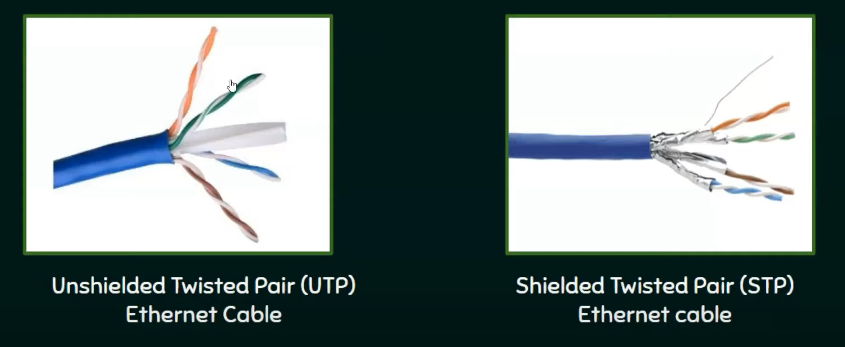
2. Copper coaxial cable – > mainly for audio and video communication
3. Fiber optic cable:
   1. Light waves
   2. High speed transmission

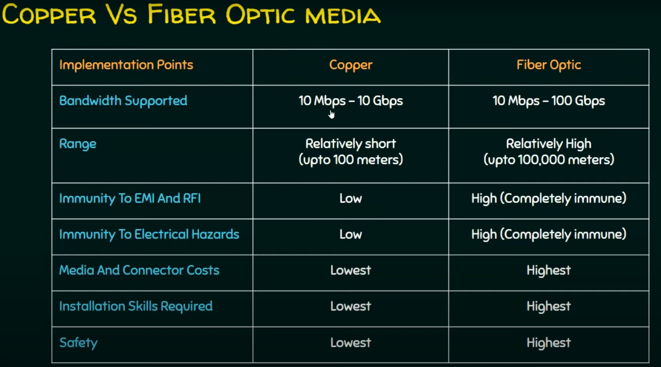

Wireless Media

1. Concerns:
   1. Coverage area
   2. Interference: 2 different waves can interfere with each other
   3. Security: No unicasting.

Wireless technologies

